Project Design Phase-II
Technology Stack (Architecture & Stack)
Date | 20 FEB 2026
Team ID | LTVIP2026TMIDS78860
Project Name | Calculating Family Expenses using Service Now
Maximum Marks | 4 Marks

Technical Architecture:
The Calculating Family Expenses using ServiceNow application is built on the ServiceNow platform, leveraging its low-code capabilities and workflow automation features to manage and monitor family financial data efficiently. The architecture consists of multiple layers — User Interface Layer, Application Layer, Process Automation Layer, and Data Layer.
At the User Interface Layer, users interact through the Service Portal, Mobile App, or Platform UI, enabling family members and administrators to input and view expense details using responsive dashboards, forms, and reports. The Application Layer includes custom tables and modules such as Expense Items, Expense Categories, and Budgets, which store structured financial data. These modules are connected through relationships and business rules to ensure data integrity.
The Process Automation Layer handles the logic and workflows for expense tracking, budget calculations, and notifications. It utilizes Flow Designer, Business Rules, and Script Includes to automate processes like expense approvals, monthly summary generation, and budget threshold alerts.
Finally, the Data Layer integrates ServiceNow’s built-in CMDB and database tables for secure and centralized data storage, ensuring that all expense records and financial information are easily retrievable and auditable. Optionally, integration with external systems (such as Excel, Google Sheets, or third-party finance APIs) can be enabled via IntegrationHub and REST APIs.

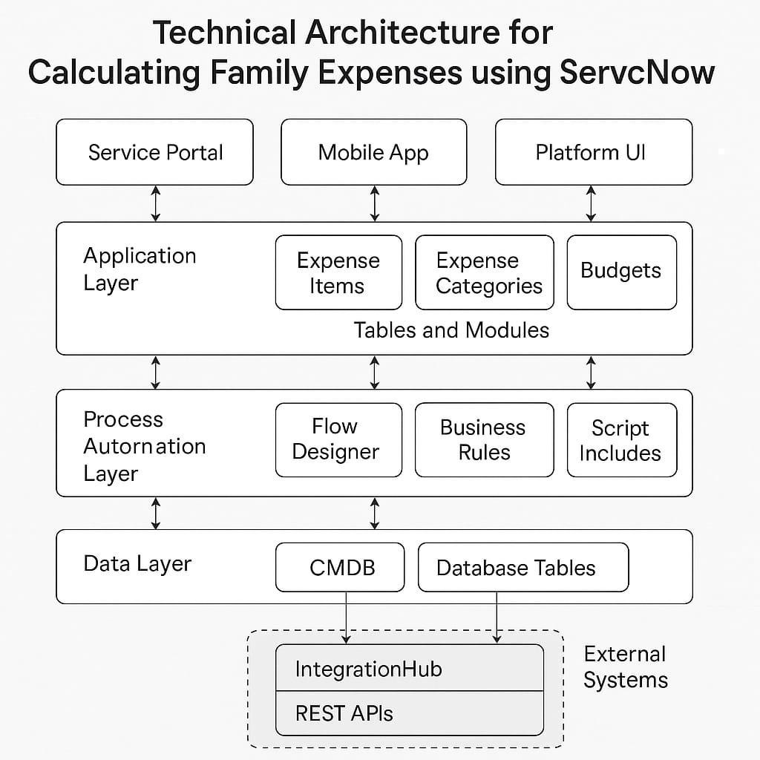

Table-1 : Components & Technologies:

Component | Description | Technology
User Interface Layer | Provides the front-end interface for family members and administrators to enter, view, and manage expenses. Includes dashboards, forms, and reports. | ServiceNow Portal, Mobile  App, Platform UI, HTML/CSS,  JavaScript
Expense Management  Module | Core application logic to handle expense entries, categories, and budgets. Manages CRUD (Create, Read, Update, Delete) operations for all expense data. | ServiceNow Custom Tables, Forms, Catalog Items
Workflow & Automation  Layer | Automates processes such as expense approvals, monthly report generation, and notifications for overspending. | Flow Designer, Business  Rules, Script Includes
Data Storage Layer | Centralized storage for all financial and expense-related information. Ensures data integrity and access control. | ServiceNow Database Tables,  CMDB
Integration Layer | Connects with external tools or financial apps for data import/export, reporting, or syncing with family financial accounts. | IntegrationHub, REST APIs, JSON
Reporting & Analytics Layer | Generates real-time dashboards, analytics, and summary reports to visualize family expenses and budget trends. | Performance Analytics,  ServiceNow Reports,  Dashboards
Security & Access Control | Defines user roles and permissions to ensure only authorized users can view or modify financial data. | ServiceNow ACLs (Access Control Lists), Roles,  Authentication
Notification & Alerts System | Sends alerts for budget limits, unusual expenses, or monthly summaries via email or mobile notification. | ServiceNow Notification  Engine, Email Scripts, Push  Notifications
System Administration & Maintenance | Manages configurations, updates, and user support for the expense management system. | ServiceNow Admin Console,  Update Sets, Instance  Configuration

Table-2: Application Characteristics:
Characteristics | Description | Technology
Platform | Core platform for developing and deploying the family expense management application. | ServiceNow Platform
User Interface Layer | Enables users to interact with the system via forms, dashboards, and mobile apps. | Service Portal, Mobile App, Platform UI
Application Layer | Contains custom tables and modules for managing expenses, categories, and budgets. | ServiceNow Custom Tables, Modules
Process Automation Layer | Automates workflows, approval processes, and notifications for expense tracking. | Flow Designer, Business  Rules, Script Includes
Data Layer | Stores all expense-related data securely with access control and audit tracking. | ServiceNow Database Tables (CMDB, Expense Tables)
Integration Layer | Enables connectivity with external financial tools, spreadsheets, and APIs. | IntegrationHub, REST API, Web Services
Reporting & Analytics | Provides dashboards and visual reports for monitoring expenses and budgets. | Performance Analytics,  Reports, Dashboards
Security & Access Control | Ensures data privacy with defined user roles and authentication. | Role-Based Access Control (RBAC), SSO
Notifications & Alerts | Sends automated alerts for budget thresholds, due dates, and approvals. | Email Notifications,  ServiceNow Notifications Engine
Scalability & Maintenance | Easily scalable for multiple family members or complex budgeting needs. | Cloud-hosted  Infrastructure | ServiceNow

